**Proceedings of the ASME 2019**

**International Mechanical Engineering Congress and Exposition**

**IMECE2019**

**November 11-14, 2019, Salt Lake City, UT, USA**

IMECE2019-11301

Coupled Flexural and Torsional Vibration Analysis of Composite Beams

|  |
| --- |
| Ehsan Sarfaraz, Jeremiah O. Afolabi, Hamid R. Hamidzadeh  Department of Mechanical and Manufacturing Engineering  Tennessee State University  Nashville, TN 37209  Email: [esarfara@my.tnstate.edu](mailto:esarfara@my.tnstate.edu), [jafolabi@my.tnstate.edu](mailto:jafolabi@my.tnstate.edu), [hhamidzadeh@tnstate.edu](mailto:hhamidzadeh@tnstate.edu) |

|  |  |  |
| --- | --- | --- |
|  |  |  |

**Abstract**

*An analytical method is presented to determine the dynamic response of a coupled flexural and torsional vibration of composite beams. The general governing equations of motion are derived and a closed form solution for free vibration of the composite beam that demonstrates both geometric and material coupling is developed. The proposed solution is used to compute the natural frequencies, modal loss factors, and mode shapes of the composite beam for several modes of the coupled bending and torsional vibrations for any boundary conditions. In this analysis, hysteretic damping for the composite beam is considered and its effects on mode shapes and modal loss factors are determined. In addition, the variation of modal parameters such as bending displacement, bending slope, torsional rotation, shear force, bending moment, and torque along the beam for the first four mode shapes are presented for the clamped-free boundary conditions. Moreover, to verify the validity of the presented analytical method, results for the cases with no damping are compared with the previously established results and good agreement is achieved. The presented results can provide a guideline for selecting appropriate geometries and materials to design composite beams.*

**Nomenclature**

$D$ Differential operator

$E$ Modulus of elasticity

$EI$ Bending rigidity

$G$ Modulus of rigidity

$GI$ Torsional rigidity

$H,h$ Bending displacement

$I$ Area moment of inertia

$I_{a}$ Mass moment of inertia per unit length

$J$ Torsion constant

$K$ Bending-torsion coupling rigidity

$k_{g}$ Geometric coupling parameter

$k_{m}$ Material coupling parameter

$L$ Length of the wing

$M$ Bending moment

$m$ Mass per unit length

$S$ Shear force

$T$ Kinetic energy

$T$ Torque

$t$ Time

$V$ Potential energy

$x_{a}$ Distance between mass and elastic axes

$y$ distance from the origin

$δ$ Variational operator

$ζ$ Non-dimensional length

$η$ Modal loss factor

$ϕ$ Bending rotation

$ψ$ Torsional rotation

$ω$ Angular frequency of oscillation

Introduction

Geometric and material coupling between bending and torsional motion of a composite structure can have many engineering applications in terrestrial, mechanical and aerospace structures such as aircraft wings, helicopter rotor blades, spacecraft, robot parts and bridges [1-3]. The design of these components require the understanding of their dynamic characteristics under specific conditions to assure their safe operation. It is well recognized that the free vibration and response behavior of composite beams can be very different from their matelic counter parts. This is primarily due to coupling between various modes of deformation that can occur in fibrous composites as a result of their anisotropic properties, but cannot generally happen in isotropic metals [3]. Among the dynamic characteristics of these structures, determining the natural frequencies and associated mode shapes and modal loss factors are of fundamental importance in the study of the free and forced vibration analyses.

Bending and torsional coupling for composite beams arises from two principal sources. One of the sources stems from non-coincident shear center and centroid of the beam cross-section such as observed in an aircraft wing. This type of coupling is referred to as geometric coupling because it only involves the geometry of the cross-section. This coupling is inertial leading to the bending and torsional motions being under static loads. The second type of coupling is the material coupling, which occurs due to fiber orientation of the composite beams and is possible under both static and dynamic loads [3]. The process of splitting the coupling terms helps to determine the contributions of the couplings together or separately to the free vibrational motion of the composite beam or in our case an aircraft wing.

On this research, the boundary condition matrix of a coupled bending and torsional composite beam was determined by taking into account the effects of both the geometric and material coupling in a unitary manner on free vibrational characteristics. The governing differential equations of motion of the composite beam are derived from the boundary conditions of a fixed and free end composite beam and analytical solutions are obtained. The Wittrick-Williams algorithm is generally used to obtaion the natural frequencies and the mode shapes from the boundary condition matrix [4]. A comparison of the results obtained with those reported in literatures is made and relevant conclusions are drawn. These results are expected to contribute to the understanding of the aeroelastic properties of the aircraft wing.

The free vibration analysis of composite beams has attracted the interest of many researchers especially due to its application in aeronautical systems [5-8]. Several approaches to solving structural vibration problems related to composite beams include analytical, numerical and experimental methods among others. The dynamic stiffness matrix method have proved to provide very accurate results as it uses exact member theory [2]. In the numerous available approaches, the coupled bending and torsional dynamic stiffness matrix of a composite beam are derived by solving the governing differential equations of motion of the beam. Therefore, a substantial body of literature is available for analysis of such structures with different geometries, material properties and boundary conditions. The relevant reported studies detailing the free vibration of the aircraft wing modelled as a composite beam and a laminated beam as well as general beam theory are thus reviewed and discussed in the following sections to build the essential background and generate the scope of this study.

Hodges et al. [5] presented methods for predicting the natural frequencies and mode shapes of composite beams. In their work they determined the elastic constants and solved the equations of motion of the composite beams using both experimental and numerical methods. They showed that the predicted free vibration characteristics of composite beams can be sensitive to the assumptions used in determining the stiffnesses. They also studied the influence of ply layup on the natural frequencies and mode shapes for thin-walled beams with circular cross-sections, and suggested that coupled extension-bending-shear modes can have frequencies that are of the same order of magnitude as the more commonly known bending-torsion modes. Armanios and Badir [6] used a variational asymptotic approach and Hamilton’s principle to derive the equations of motion for the free vibration analysis of anisotropic thin-walled closed-section beams. They obtained closed-form expressions for the stiffness coefficients and also the influence of coupling on the natural frequencies of the beams.

Abrahamovic and Livshits [7] studied free vibrations of non-symmetrically laminated cross-ply composite beams based on Timshenko beam theory. In their work they accounted for the contributions of longitudinal and shear deformation, as well as rotary inertia. They solved the equations of motion and obtained natural frequencies and vibration modes for their composite beams. Yuan and Miller [8] investigated laminated composite beams and derived a finite element method to solving the associated equations of motions. They obtained stresses and deflections for beams with any number of laminae and their results agree well with those reported by both theoretical and experimental approaches.

Chen et al. [9] applied the technique of differential quadrature to investigate the free vibration problems of general anisotropic beams as well as laminated beams. Their technique showed that natural frequency of laminated beams increases with the number of layers for each vibration mode but as the number of layers tend to infinity or becomes significantly large, the natural frequency remains invariable. Song and Librescu [10] studied the free vibration of a cantilevered composite aircraft wing structure modelled as an anisotropic composite thin-walled beam of closed contour. They compared the bending stiffness obtained for several bending vibration mode and concluded that larger ply angles yield higher bending Eigen frequencies, while incorporating transverse shear flexibility into the model leads to lower Eigen frequencies. Eslimy-Isfany and Banerjee [11] developed a theory to perform response analysis of a bending-torsion materially coupled composite beam subjected to deterministic and random loads. They applied the work of Armanios and Badir [6] to investigate the influence of coupling on natural frequencies of composite beams. They reported a trend between mode shapes and ply angle which indicated that for a bending-torsion coupled analysis with ply angles less than 10, the mode is predominantly bending but becomes torsional between ply angles of 10 and 25. However, the mode becomes bending-dominated again as angle increases from 25 to about 75.

Qin and Librescu [12] provided a similar analysis to Eslimy-Isfany and Banerjee [11] but in place of random and deterministic loads they performed their analysis in an incompressible flow with the beams exposed to gust and blast loads. Their model incorporated transverse shear, material anisotropy, warping inhibition and rotary inertia. They observed that the fluid-wing interaction provided damping to the response. Finally, they observed that for aircraft wings with large aspect ratio, warping inhibition had marginal influence on the response irrespective of the fluid-wing interaction. Wittrick and Williams [4] developed what is popular known as the Wittrick-Williams algorithm for determining the natural undamped frequencies of vibration of any linear elastic structure provided the dynamic stiffness matrix corresponding to any finite set of displacement is known. This is significant has the aircraft wing falls under this very broad umbrella. Banerjee [1] in one of the earliest consideration of a coupled bending-torsion analysis to obtain dynamic stiffness matrix for beam elements gave a framework to derive exact solutions for the governing equation of a beam using the dynamic stiffness method. Banerjee et al. [3] obtained the dynamic stiffness matrix of a composite beam that exhibits both geometric and material coupling between bending and torsional motions. They applied the Wittrick-Williams algorithm to the dynamic stiffness matrix to obtain natural frequencies and mode shapes. Their result showed that geometric and material coupling had significant effect on the natural frequencies and mode shapes obtained.

Kant and Gupta [13] developed a theory for a higher order shear deformable beam model based on higher order displacement. They incorporated linear and quadratic variation of transverse normal strain and shearing strain through the beam thickness. Their finite element model showed that for thick beams the classical theory underpredicts displacement and overpredicts natural frequencies while for thin beams there is a good convergence. Chandrashekhara at al. [14] predicted the natural frequencies of symmetrically laminated composite beams using first-order shear deformation theory. They reported that for long-thin beams the theory indicated no effect of shear deformation, but for short-thick beams, the theory overpredicts the natural frequencies indicating that there is a significant effect of shear deformation for higher modes. They also concluded that the non-dimensional natural frequencies decrease with increase in fiber orientation of the beam. Marur and Kant [15] proposed and tested three higher order displacement finite element models for the free vibration of reinforced composite beams. Their theories model the warping of the cross-section by taking the cubic variation of axial strain and assumed a quadratic shear strain variation across the depth of the cross-section. Their model computed higher frequencies than those of the first order theory for thin beams, but lower frequencies than those of the Timoshenko theory for thick beams.

Lottati [16] investigated the influence of bending-torsion stiffness coupling on the flutter and divergence dynamic pressure on a cantilever wing. Here, an optimization procedure was used to obtain exact solutions for the coupled bending-torsion equations for a cantilevered beam. He concluded that an attempt to eliminate divergence of a swept forward wing by the composite bending-torsion stiffness coupling might lower the flutter velocity of the wing. Lottati [17] had carried out similar analysis earlier but for a wing carrying a fuselage at its semispan, a pylon at the wing tip and the aircraft was modelled as in a free-flight condition (unrestrained vehicle). However, the flutter instability of the unrestrained vehicle is more critical than the divergence mode of the instability. Therefore, to alleviate this flutter instability aeroelastic tailoring of the wing can be applied.

Finally, in one of the earliest works on the aerodynamics and flutter of airplane wings, Goland [18] examined the flutter of a uniform cantilever wing. He argued that his method which is used to calculate the flutter speed of a uniform wing carrying an arbitrarily placed concentrated load can be extended to more than a single load. He concluded that the location of such loads or masses might be used to increase the flutter speed of a given wing.

The aim of this paper is to present the modal vibration analysis to obtain the natural frequencies and their corresponding mode shapes and modal loss factors. This modal analysis takes into account hysteretic damping of materials in the composite beams. Damping is the conversion of mechanical energy of a vibrating structure into thermal energy. Hysteretic damping is a form of internal damping that occurs in solid materials and structures which have been subjected to cyclic stresses [19]. In this study, it is assumed that the material damping is independent of the frequency and occurs through the internal friction as particles within a material slip and slide at internal planes during shear deformation. The material damping depends on factors such as type of materials, stress amplitude, internal forces, the number of cycles, sizes of geometry, the quality of the surface and temperature [14]. The modal loss factors associated with the obtained natural frequencies would also be obtained and investigated. The modal loss factor of a material is defined as the ratio of the energy dissipated per cycle to maximum strain energy stored. Finally, the mode shapes associated with the analysis is obtained and observed. The mode shape is simply the displacements of all the reference point on the system. This work is expected to perform free vibration modal analysis for a composite beam with application in an aircraft wing.

**Governing equations**

This section provides development of the governing equations of motion for a coupled bending and torsional vibration of a composite beam. An aircraft wing is an example of this composite beam as it exhibits both geometric and material coupling [11]. In an aircraft, the wings are principal load-carrying structures which provide the necessary lift for the air vehicle. Figure 1 shows a right-handed coordinate system of the composite beam. The elastic axis, which coincides with the $Y$-axis, is chosen to be the locus of the geometric shear centers of the wing cross-section. It is allowed to deflect out of the plane by $h \left(y,t\right)$,whilst the cross-section is allowed to rotate about $OY$ by $ψ \left(y,t\right)$,where $y$ and $t$ denote distance from the origin and time, respectively. The wing has a length of $L$, bending rigidity $EI$, torsional rigidity $GJ$, bending–torsion coupling rigidity $K$, mass per unit length $m$, and mass moment of inertia per unit length $I_{α}$ about the $Y$-axis, respectively. In the figure, $x_{α}$ is the distance between the mass and elastic axes, which are, respectively, the loci of the mass center (centroid) and the shear center of the wing cross-sections, and is positive when the mass axis is near of the elastic axis as shown. The two principal parameters that are responsible for the geometric and material coupling are $x_{α}$ and $K$, respectively [3].

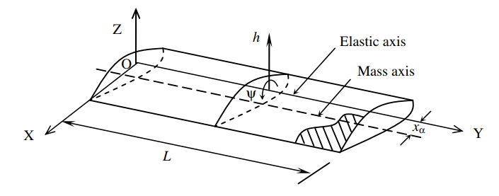

Figure 1.The coordinate system and notation for bending-toresion coupled composite beam

To derive the associated equations of motion for our composite beam, the potential energy and kinetic energy equations reported by Lottati [16,17] was employed, and is given as

$T=\frac{1}{2}\int_{0}^{L}{\left[m(({\dot{h})}^{2}-2mx_{α}\dot{h}\dot{ψ}+I_{α}({\dot{ψ})}^{2}\right]dy}$ (1)

$V=\frac{1}{2}\int_{0}^{L}{\left[EI(({h'')}^{2}+2Kh''ψ'+GJ({ψ')}^{2}\right]dy}$ (2)

Here a prime and over dot represents partial differentiation with respect to position $y$ and time $t$, respectively. Using Hamilton’s principle which states that

$δ\int_{t_{1}}^{t_{2}}{\left(T-V\right)dt=0}$ (3)

Where $δ$ is the variational operator and $t_{2}$ and $t_{1}$ are the time intervals of the dynamic trajectory. From equations (1), (2) and (3) we obtain two equations

$EIh^{''''}+Kψ^{'''}+m\ddot{h}-mx_{α}\ddot{ψ}=0$ (4)

$GJψ^{''}+Kh^{'''}-I_{α}\ddot{ψ}+mx_{α}\ddot{h}=0$ (5)

The expressions for the shear force ($S$), bending moment ($M$) and Torque ($T$) distributions across the length of the beam from the Hamiltonian formulation as follows

$S=EIh^{'''}+Kψ^{''}$ (6)

$M=-EIh^{''}-Kψ^{'}$ (7)

$T=-Kh^{''}-GJψ^{'}$ (8)

Assuming harmonic oscillation for $h$ and $ψ$ results to the following equations

$\left.\begin{aligned}h\left(y,t\right)=H\left(y\right)e^{-iωt} \\ ψ\left(y,t\right)= Ψ(y)e^{-iωt}\end{aligned} \right\}$ (9)

Where $ω$ is the circular frequency of oscillation, $H$ and $Ψ$ are the amplitudes of $h$ and $ψ$, respectively. Substituting equation (9) into equations (4) and (5) gives

$EIH^{''''}+KΨ^{'''}-mω^{2}H+mω^{2}x_{α}Ψ=0$ (10)

$GJΨ^{''''}+KH^{'''}+I_{α}ω^{2}Ψ-mω^{2}x_{α}H=$ (11)

Introducing the non-dimensional length $ζ$, and the differential operator $D$ as follows

$\left.\begin{aligned}ζ= \frac{y}{L} \\ D= \frac{d}{dζ}\end{aligned} \right\}$ (12)

Then, equations (9) through (11) can be expresses as follows

$\left[{\frac{EID^{4}}{L^{4}}-mω^{2} \atop \frac{KD^{3}}{L^{3}}-mω^{2}x_{α}} {\frac{KD^{3}}{L^{3}}+mω^{2}x_{α} \atop \frac{GJD^{4}}{L^{2}}+I_{α}ω^{2}}\right]\left\{{\begin{aligned}H\left(ζ\right)\end{aligned} \atop Ψ(ζ)}\right\}=\left\{{\begin{aligned}0\end{aligned} \atop 0}\right\}$ (13)

Thus, solutions to the bending displacement $H$ (𝜁) as well as the torsional rotation $Ψ$ (𝜁) are

$\left[\left(EI\frac{D^{4}}{L^{4}}-mω^{2}\right)\left(GJ\frac{D^{2}}{L^{2}}+I_{α}ω^{2}\right)-\left(K^{2}\frac{D^{6}}{L^{6}}-m^{2}ω^{4}x_{α}^{2}\right)\right]H\left(ζ\right)=0$ (14)

$\left[\left(EI\frac{D^{4}}{L^{4}}-mω^{2}\right)\left(GJ\frac{D^{2}}{L^{2}}+I_{α}ω^{2}\right)-\left(K^{2}\frac{D^{6}}{L^{6}}-m^{2}ω^{4}x_{α}^{2}\right)\right]Ψ\left(ζ\right)=0$ (15)

After simplification, equations (14) and (15) can be condensed into a sixth order ordinary differential equation as shown below

$\left[\left(EIGJ-K^{2}\right)\frac{D^{6}}{L^{6}}+\left(EII_{α}ω^{2}\right)\frac{D^{4}}{L^{4}}-\left(mω^{2}GJ\right)\frac{D^{2}}{L^{2}}-mω^{4}I_{α}+m^{2}ω^{4}x_{α}^{2}\right] H\left(ζ\right)=0$ (16)

$\left[\left(EIGJ-K^{2}\right)\frac{D^{6}}{L^{6}}+\left(EII_{α}ω^{2}\right)\frac{D^{4}}{L^{4}}-\left(mω^{2}GJ\right)\frac{D^{2}}{L^{2}}-mω^{4}I_{α}+m^{2}ω^{4}x_{α}^{2}\right] Ψ\left(ζ\right)=0$ (17)

Each of the above equations can be represented by the following equation

$\left[D^{6}+aD^{4}-bD^{2}-abc\right]W=0$ (18)

Where $W$ is $H$ (𝜁) or $Ψ(ζ)$ and $a$ and $b$ define as

$a=\frac{\frac{EII_{α}ω^{2}}{L^{4}}}{EIGJ-K^{2})/L^{6}}=\frac{\frac{I_{α}ω^{2}L^{2}}{GJ}}{1-\frac{K^{2}}{EIGJ}}$ (19)

$b=\frac{GJmω^{2}/L^{2}}{EIGJ-K^{2})/L^{6}}=\frac{(mω^{2}L^{4})/EI}{1-\frac{K^{2}}{EIGJ}}$ (20)

Introducing $\overline{a}, \overline{b} and K_{m}$

$\overline{a}=\frac{I_{α}ω^{2}L^{2}}{GJ}$ (21)

$\overline{b}=\frac{mω^{2}L^{4}}{EI}$ (22)

$K_{m}=\frac{K^{2}}{EIGJ}$ (23)

Then, equations (19) and (20) can be written as equations (24) and (25) respectively

$a=\frac{\overline{a}}{1-K_{m}}$ (24)

$b=\frac{\overline{b}}{1-K_{m}}$ (25)

From equations (16), (17) and (18)

$abc=\frac{mω^{2}I_{α}-m^{2}ω^{4}x_{α}^{2}}{EIGJ-\frac{K^{2}}{L^{6}}}$ (26)

After simplification,

$abc=\frac{{(mω^{2}L^{4}}/{EI)({I_{α}ω^{2}L^{2}}/{GJ)(1-\frac{mx_{α}^{2}}{I_{α}})(1-K_{m})}}}{(1-K_{m})(1-K_{m})}$ (27)

Recall, equations (21) and (22), Therefore, equation (27) becomes

$abc=\left(\frac{\overline{a}}{1-K_{m}}\right)\left(\frac{\overline{b}}{1-K_{m}}\right)\left(1-\frac{mx_{α}^{2}}{I_{α}}\right)\left(1-K_{m}\right)$ (28)

Also recalling equations (24) and (25), and let

$K_{g}=\frac{mx_{α}^{2}}{I_{α}}$ (29)

Therefore,

$c=\left(1-K_{g}\right)\left(1-K_{m}\right)$ (30)

The solution to the differential equation (18) is obtained by considering $α_{n}\left(n=1,2,3\right)$ to be complex roots of the characteristic equation

$H\left(ζ\right)=A_{1}e^{α_{1}ζ}+A_{2}e^{-α_{1}ζ}+A_{3}e^{α_{2}ζ}+A_{4}e^{-α_{2}ζ}+A_{5}e^{α_{3}ζ}+A_{6}e^{-α_{3}ζ}$ (31a)

$Ψ\left(ζ\right)= B_{1}e^{α_{1}ζ}+B_{2}e^{-α_{1}ζ}+B_{3}e^{α_{2}ζ}+B_{4}e^{-α_{2}ζ}+B_{5}e^{α_{3}ζ}+B_{6}e^{-α_{3}ζ}$ (31b)

$Θ\left(ζ\right)= A_{1}{α_{1}e}^{α_{1}ζ}-A_{2}α_{1}e^{-α_{1}ζ}+A_{3}α_{2}e^{α_{2}ζ}-A_{4}α_{2}e^{-α_{2}ζ}+A_{5}α_{3}e^{α_{3}ζ}-A_{6}α_{3}e^{-α_{3}ζ}$ (31c)

Substituting equations (31a) and (31b) into the first expressions of $H$ and $Ψ$ in equation (13) gives

$\left(\frac{EI}{L^{4}}α_{1}^{4}-mω^{2}\right)\left(A_{1}e^{α_{1}ζ}+A_{2}e^{{-α}_{1}ζ}\right)+\left(\frac{EI}{L^{4}}α_{2}^{4}-mω^{2}\right)\left(A_{3}e^{α_{2}ζ}+A_{4}e^{{-α}_{2}ζ}\right)+\left(\frac{EI}{L^{4}}α_{3}^{4}-mω^{2}\right)\left(A_{5}e^{α_{3}ζ}+A_{6}e^{{-α}_{3}ζ}\right)+\left(\frac{K}{L^{3}}α_{1}^{3}+mω^{2}x_{α}\right)\left(B_{1}e^{α_{1}ζ}\right)+ \left(-\frac{K}{L^{3}}α_{1}^{3}+mω^{2}x_{α}\right)\left(B_{2}e^{-α_{1}ζ}\right)+\left(\frac{K}{L^{3}}α_{2}^{3}+mω^{2}x_{α}\right)\left(B_{3}e^{α_{2}ζ}\right)+\left(-\frac{K}{L^{3}}α_{2}^{3}+mω^{2}x_{α}\right)\left(B_{4}e^{-α_{2}ζ}\right)+\left(\frac{K}{L^{3}}α_{3}^{3}+mω^{2}x_{α}\right)\left(B_{5}e^{α_{3}ζ}\right)+\left(-\frac{K}{L^{3}}α_{3}^{3}+mω^{2}x_{α}\right)\left(B_{6}e^{{-α}_{3}ζ}\right)=0$ (32)

Thus we conclude that the two sets of constants $A_{1}-A_{6}$ and $B_{1}-B_{6}$ are related according to the following equations

$B_{1},B_{2}=\frac{\frac{EI}{L^{4}}(-α_{1}^{4}+\overline{b})}{\frac{K}{L^{3}}(±α_{1}^{3}+\frac{mω^{2}x_{α}}{K/{L^{3}}})}= A_{1},A_{2}$ (33)

$B_{3},B_{4}=\frac{\frac{EI}{L^{4}}(-α_{2}^{4}+\overline{b})}{\frac{K}{L^{3}}(±α_{2}^{3}+\frac{mω^{2}x_{α}}{K/{L^{3}}})}=A_{3},A_{4}$ (34)

$B_{5},B_{6}=\frac{\frac{EI}{L^{4}}(-α_{3}^{4}+\overline{b})}{\frac{K}{L^{3}}(±α_{3}^{3}+\frac{mω^{2}x_{α}}{K/{L^{3}}})}=A_{5},A_{6}$ (35)

Where the odd constant $B_{1,3,5} and A_{1,3,5}$ represents values carrying the positive sign and the even constants $B_{2,4,6,} and A_{2,4,6}$ represents values with the negative sign. Introducing $K_{δ}$ and $x_{α}$ as follows

$K_{δ}=\frac{EI}{KL}x_{α}$ (36)

$x_{α}=\frac{KLK_{δ}}{EI}$ (37)

Substituting equations (36) and (37) into equations (33), (34) and (35), we obtain the final relation between $B_{i} and A_{i} (i=1,2….6)$ as follows

$B_{1},B_{2}=\frac{K_{α_{1}}}{L\left[±1+g_{α_{1}}\right]}= A_{1},A_{2}$ (38)

$B_{3},B_{4}=\frac{K_{α_{2}}}{L\left[±1+g_{α_{2}}\right]}= A_{3},A_{4}$ (39)

$B_{5},B_{6}=\frac{K_{α_{3}}}{L\left[±1+g_{α_{3}}\right]}= A_{5},A_{6}$ (40)

Where

$K_{α_{i}}=\frac{EI}{K}\left(\frac{\overline{b}-α_{i}^{4}}{α_{i}^{3}}\right)$ (41)

$g_{α_{i}}=\frac{K_{δ}\overline{b}}{α_{i}^{3}}$ (42)

The expressions for shear force ($S$), bending moment ($M$) and Torque ($T$) obtained in equations (6), (7) and (8) respectively can be solved as follows

$$S=\frac{EI}{L^{3}}\left[A_{1}α_{1}^{3}e^{α_{1}ζ}-A_{2}α_{1}^{3}e^{{-α}_{1}ζ}+A_{3}α_{2}^{3}e^{α_{2}ζ}-A_{4}α_{2}^{3}e^{-α_{2}ζ}+A_{5}α_{3}^{3}e^{α_{3}ζ}-A_{6}α_{3}^{3}e^{-α_{3}ζ}\right]+\frac{K}{L^{2}}\left[B_{1}α_{1}^{2}e^{α_{1}ζ}-B_{2}α_{1}^{2}e^{{-α}_{1}ζ}+B_{3}α_{2}^{2}e^{α_{2}ζ}-B_{4}α_{2}^{2}e^{-α_{2}ζ}+B_{5}α_{3}^{2}e^{α_{3}ζ}-B_{6}α_{3}^{2}e^{-α_{3}ζ}\right]$$

(43)

The shear force can also be written in the form below

$$S=\left[\frac{EIα_{1}^{3}}{L^{3}}+\frac{KK_{α_{1}}}{L^{3}(1+g_{α_{1}})}\right]A_{1}e^{α_{1}ζ}-\left[\frac{EIα_{1}^{3}}{L^{3}}+\frac{KK_{α_{1}}}{L^{3}(-1+g_{α_{1}})}\right]A_{2}e^{-α_{1}ζ}+\left[\frac{EIα_{2}^{3}}{L^{3}}+\frac{KK_{α_{2}}}{L^{3}(1+g_{α_{2}})}\right]A_{3}e^{α_{2}ζ}-\left[\frac{EIα_{2}^{3}}{L^{3}}+\frac{KK_{α_{2}}}{L^{3}(-1+g_{α_{2}})}\right]A_{4}e^{-α_{2}ζ}+\left[\frac{EIα_{3}^{3}}{L^{3}}+\frac{KK_{α_{3}}}{L^{3}(1+g_{α_{3}})}\right]A_{5}e^{α_{3}ζ}-\left[\frac{EIα_{3}^{3}}{L^{3}}+\frac{KK_{α_{3}}}{L^{3}\left(-1+g_{α_{3}}\right)}\right]A_{6}e^{-α_{3}ζ}$$

(44)

The bending moment can also be written in two forms as shown below

$$M=-\frac{EI}{L^{2}}\left[A_{1}α_{1}^{2}e^{α_{1}ζ}-A_{2}α_{1}^{2}e^{{-α}_{1}ζ}+A_{3}α_{2}^{2}e^{α_{2}ζ}-A_{4}α_{2}^{2}e^{-α_{2}ζ}+A_{5}α_{3}^{2}e^{α_{3}ζ}-A_{6}α_{3}^{2}e^{-α_{3}ζ}\right]-\frac{K}{L}\left[B_{1}α_{1}e^{α_{1}ζ}-B_{2}α_{1}e^{{-α}_{1}ζ}+B_{3}α_{2}e^{α_{2}ζ}-B_{4}α_{2}e^{-α_{2}ζ}+B_{5}α_{3}e^{α_{3}ζ}-B_{6}α_{3}e^{-α_{3}ζ}\right]$$

(45)

$M=-\left[\frac{EIα_{1}^{2}}{L^{2}}+\frac{Kα_{1}K_{α_{1}}}{L^{2}\left(1+g_{α_{1}}\right)}\right]A_{1}e^{α_{1}ζ}+\left[\frac{EIα_{1}^{2}}{L^{2}}+\frac{Kα_{1}K_{α_{1}}}{L^{2}(-1+g_{α_{1}})}\right]A_{2}e^{-α_{1}ζ}-\left[\frac{EIα_{2}^{2}}{L^{2}}+\frac{Kα_{2}K_{α_{2}}}{L^{2}\left(1+g_{α_{2}}\right)}\right]A_{3}e^{α_{2}ζ}+\left[\frac{EIα_{2}^{2}}{L^{2}}+\frac{Kα_{2}K_{α_{2}}}{L^{2}(-1+g_{α_{2}})}\right]A_{4}e^{-α_{2}ζ}-\left[\frac{EIα_{3}^{3}}{L^{2}}+\frac{Kα_{3}K_{α_{3}}}{L^{2}\left(1+g_{α_{3}}\right)}\right]A_{5}e^{α_{3}ζ}+\left[\frac{EIα_{3}^{3}}{L^{2}}+\frac{Kα_{3}K_{α_{3}}}{L^{2}\left(-1+g_{α_{3}}\right)}\right]A_{6}e^{-α_{3}ζ}$ (46)

Similarly, the Torque can also be written in two forms as shown below

$$T=-\frac{K}{L^{2}}\left[A_{1}α_{1}^{2}e^{α_{1}ζ}-A_{2}α_{1}^{2}e^{{-α}_{1}ζ}+A_{3}α_{2}^{2}e^{α_{2}ζ}-A_{4}α_{2}^{2}e^{-α_{2}ζ}+A_{5}α_{3}^{2}e^{α_{3}ζ}-A_{6}α_{3}^{2}e^{-α_{3}ζ}\right]-\frac{GJ}{L}\left[B_{1}α_{1}e^{α_{1}ζ}-B_{2}α_{1}e^{{-α}_{1}ζ}+B_{3}α_{2}e^{α_{2}ζ}-B_{4}α_{2}e^{-α_{2}ζ}+B_{5}α_{3}e^{α_{3}ζ}-B_{6}α_{3}e^{-α_{3}ζ}\right]$$ (47)

$T=-\left[\frac{Kα_{1}^{2}}{L^{2}}+\frac{GJα_{1}K_{α_{1}}}{L^{2}\left(1+g_{α_{1}}\right)}\right]A_{1}e^{α_{1}ζ}+\left[\frac{Kα_{1}^{2}}{L^{2}}+\frac{GJα_{1}K_{α_{1}}}{L^{2}(-1+g_{α_{1}})}\right]A_{2}e^{-α_{1}ζ}-\left[\frac{Kα_{2}^{2}}{L^{2}}+\frac{GJα_{2}K_{α_{2}}}{L^{2}\left(1+g_{α_{2}}\right)}\right]A_{3}e^{α_{2}ζ}+\left[\frac{Kα_{2}^{2}}{L^{2}}+\frac{GJα_{2}K_{α_{2}}}{L^{2}(-1+g_{α_{2}})}\right]A_{4}e^{-α_{2}ζ}-\left[\frac{Kα_{3}^{3}}{L^{2}}+\frac{GJα_{3}K_{α_{3}}}{L^{2}\left(1+g_{α_{3}}\right)}\right]A_{5}e^{α_{3}ζ}+\left[\frac{Kα_{3}^{3}}{L^{2}}+\frac{GJα_{3}K_{α_{3}}}{L^{2}\left(-1+g_{α_{3}}\right)}\right]A_{6}e^{-α_{3}ζ}$ (48)

**Modal displacements, SHEAR, MOMENT, AND TOURQE**

The dynamic stiffness matrix of the composite beam is formulated by applying the boundary conditions for the associated boundary displacements and reactions.

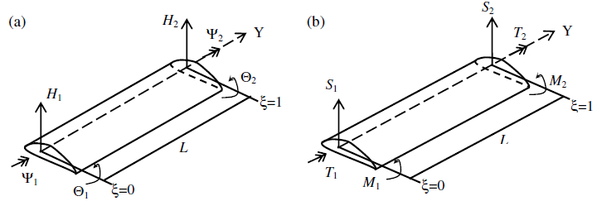

Figure 2. Boundary conditions for displacements and forces. (a) displacements, (b) forces

The boundary conditions for displacements at $ζ = 0$ and 1 are applied to equations (31a-c)

For the fixed end, $ζ = 0$

${\left\{Q\right\}}_{F_{x}}={\left[R(0,ω)\right]}_{F_{x}}\left\{A\right\}$ (49)

For the free end, $ζ =1$

${\left\{Q\right\}}_{F_{r}}={\left[R(1,ω)\right]}_{F_{r}}\left\{A\right\}$ (50)

A relation between the fixed end and free end conditions is obtained as follows

${\left\{Q\right\}}_{F_{r}}={\left[R\right]}_{F_{r}}{\left[R\right]}_{F_{x}}^{-1}{\left\{Q\right\}}_{F_{x}}$ (51)

Where ${\{Q\}}^{T}=\{H,θ,ψ,S,M,T\}$, $F_{r}$ and $F_{x}$ represents free end and fixed end respectively. Detailed representation of the matrices in equations (49) and (50) can be found in Appendix A.

The dynamic stiffness matrix is obtained by eliminating the constant vector A in equations (49) and (50), and relating the amplitude of the forces to those of the displacement at the ends of the composite beam.

The natural frequencies and the mode shapes of a coupled bending and torsional composite beam are obtained with the boundary condition based matrix that is developed.

**Natural frequency and MODAL LOSS FACTOR**

For the fixed end $H$, $θ$ and $ψ$ are all zero, while for the free end $S, T$ and $M$ are all zeros, so we obtain a $3×3$ matrix, where the natural frequencies of the system is calculated.

$\left[\begin{matrix}{\overline{r}}_{44} & {\overline{r}}_{45} & {\overline{r}}_{46} \\ {\overline{r}}_{54} & {\overline{r}}_{55} & {\overline{r}}_{56} \\ {\overline{r}}_{64} & {\overline{r}}_{65} & {\overline{r}}_{66}\end{matrix}\right]{\left\{\begin{matrix}S \\ T \\ M\end{matrix}\right\}}_{F_{x}}=\left\{\begin{matrix}0 \\ 0 \\ 0\end{matrix}\right\}$ (52)

Note that the determinant of the $\left[\overline{R}\right]$ matrix in equation (52) above gives the frequency equations for ${ ω}_{i}=1,2,3, and 4$. The mode shapes for this analysis is obtained from a plot of $H_{i},θ_{i},ψ_{i},S_{i},M_{i},T_{i}$ as a function of $ζ$. It should be noted that $i=1,2,3 and 4$ give the four mode shapes.

This function solves the characteristics equation from (18) and uses the stiffness and mass properties used by Goland [18]. The basic data used for the aircraft wing are given in the following table:

|  |  |  |  |  |
| --- | --- | --- | --- | --- |
| Bending Rigidity ( $EI, Nm^{2})$ | Torsional Rigidity  ( $GJ, Nm^{2})$ | Mass per unit length $${(kg}/m)$$ | Mass moment of inertia per unit length ( $I_{α}, kgm)$ | Length of the wing $(L,m)$ |
| $$9.75×{10}^{6}$$ | $$9.88×{10}^{5}$$ | $$35.75$$ | $$8.65$$ | $$6$$ |

Second function solves the characteristics equation and is used to obtain the mode shapes for the first four modes.

Third function uses the characteristic equation developed to estimate the natural frequencies of a composite beam without damping and obtains the roots of the characteristic equation in equation (18) for 400,000 different frequencies all within the expected frequency range. Implementing boundary conditions into equations (49) and (50), provides the variation of the determinants which is a complex value against the expected frequencies and the expected modal loss factors. Keep this result to fed into the case where material damping is considered.

The last function integrates the above functions to produce complex natural frequencies, mode shapes and modal loss factor associated with a coupled bending-torsion composite beam and predicts the variation of the determinant with the expected modal loss factor and frequency for the first four modes. The function computes complex natural frequencies within a frequency window of -5 Hz to 5 Hz and range of 10,000 points. Furthermore, it computes for 301 points within the range 0-0.3 both resulting in a 0.001 accuracy to consider the loss factor. The lowest absolute value or the absolute minimum of the determinant from the function correspond to the complex natural frequency of the system. Using hysteretic damping model [19] for the composite beam the natural frequency is obtained in the form of a complex modulus as follows:

$ω^{*}= ω\left(1+iη^{*}\right)$ (53)

Where $ω^{*}$ the complex natural frequency and η is the damping factor. The modal loss factor than be obtained from equation (53) as follow

$ω^{*^{2}}=ω_{n}^{2}\left(1+iη_{loss factor}\right)$ (54)

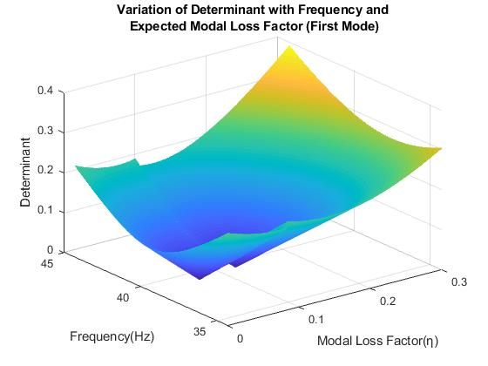Note that $ω_{n}$ is different from ω and $η_{loss factor}$ is the modal loss factor. The mesh for the absolute minimum value corresponding to the natural frequency is obtained for the first four modes as shown in figure 3 to figure 6 below.

Figure 3.The first mode shape as obtained by the dynamic stiffness method for a coupled bending-torsional composite beam

Figure 3, shows the variation of the determinant of the system with frequency and modal loss factor. For the first mode, the frequency range was 35 Hz – 45 Hz and for the modal loss factor the range was 0.3, to give an estimation to 0.001 accuracy. It can be observed that the absolute minimum or the natural frequency occurs at 39 Hz and the modal loss factor of 0.08. Clearly, the frequency and modal loss factor affect the mode shapes.

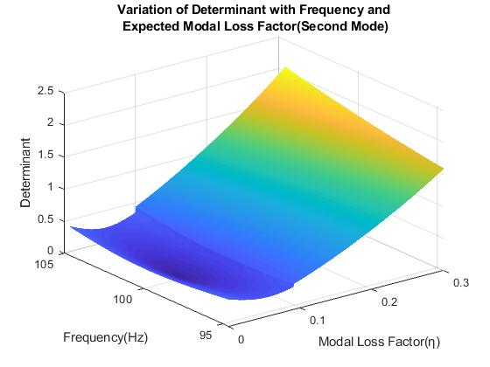

Figure 4. The second mode shape as obtained by the dynamic stiffness method for a coupled bending-torsional composite beam

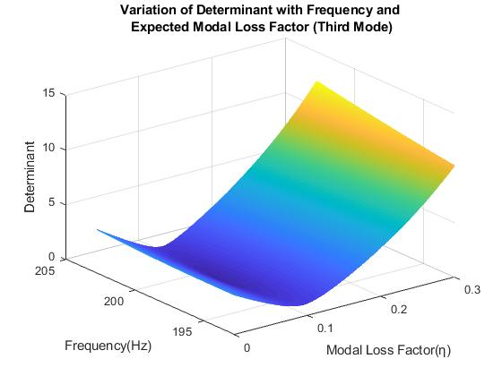Similarly, Figure 4 shows the variation of the determinant of the system with frequency and modal loss factor. For the second mode, the frequency range was 95Hz - 105Hz and for the modal loss factor the range was 0.3, to give an estimation to 0.001 accuracy. Clearly, the second mode shows the presence of the bending-torsional coupling and the effect of the coupling on determinant obtained, which is slightly lower than the first mode. Therefore it is clear that the natural frequencies and mode shapes for the case where coupling is present and the case without coupling are different.

Figure 5. The third mode shape as obtained by the dynamic stiffness method for a coupled bending-torsional composite beam

Figure 5 shows the variation of the determinant of the system with frequency and modal loss factor. For the third mode, the frequency range was 195Hz - 205Hz and for the modal loss factor the range was 0.3, to give an estimation to 0.001 accuracy. The third mode shows even more coupling between the bending and torsional motions of the composite beam. It can be observed from the third mode that as the expected frequency range increases, the natural frequency increases but the modal loss factor slightly changes and stays fairly at 0.12 as observed in the second mode.

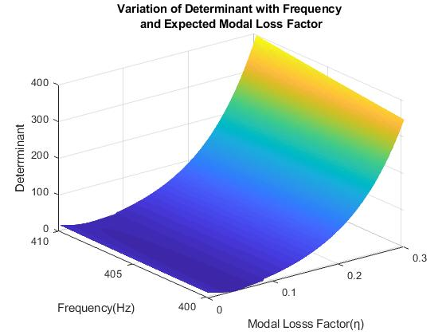

Figure 6. The fourth mode shape as obtained by the dynamic stiffness method for a coupled bending-torsional composite beam

Figure 6 shows the variation of the determinant of the system with frequency and modal loss factor. For the fourth mode, the frequency range was 400Hz - 410Hz and for the modal loss factor the range was 0.3, to give an estimation to 0.001 accuracy. The fourth mode shows similar coupling between the bending and torsional motions of the composite beam as the third mode. However the fourth mode indicated a slightly lower modal loss factor than the second and third mode. This difference can have considerable importance in the design of composite wings.

The next set of results are from solving for displacement parameters from equation (49), and the reactional parameters from equation (50). These results highlight the mode shapes of the composite beams.

The results shown in figures 7-12, show that the geometrical parameters and material properties of the composite beam structure have very important effect on the dynamics of the system. The variations observed for the four modes for bending displacement, bending rotation, torsional rotation, shear force, bending moment and torque, with the corresponding modal loss factors can be used for vibration tuning of hysteretically damped mechanical systems. Also, the modal loss factor obtained provides a suitable framework to introduce desired structural modifications to beam structures, since it helps in the determination of the required quantity of modal loss factor for such system.

**COMPARISON**

In order to validate the analytical procedure and solutions obtained, the results from this analysis were compared with established results from literature. As reported by Banerjee [3], Table 1 shows a comparison between the natural frequencies of a cantilever composite wing that exhibits coupling between bending and torsional motion and the natural frequencies obtained from the no damping condition detailed above for the first three modes.

Table 1. Compariosn the natural frequencies Banerjee [3]

|  |  |  |  |
| --- | --- | --- | --- |
|  | | Natural Frequencies $ω_{1}$ (rad/s) | |
| $x_{α}$ (m) | *K ${(10}^{6}Nm^{2})$* | $*$ Reference | Result |
| 0.1 | 1.5 | 40.252 | 39.232 |
| 0.1 | 2 | 33.962 | 32.580 |
| 0.2 | 1.5 | 38.071 | 36.705 |
| 0.2 | 2 | 31.981 | 43.188 |
|  | | **Natural Frequencies $ω_{2}$ (rad/s)** | |
| $x_{α}$ (m) | *K ${(10}^{6}Nm^{2})$* | $*$ Reference | Result |
| 0.1 | 1.5 | 99.072 | 99.589 |
| 0.1 | 2 | 100.47 | 101.234 |
| 0.2 | 1.5 | 112.220 | 113.273 |
| 0.2 | 2 | 114.710 | 112.821 |
|  | | **Natural Frequencies $ω_{3}$ (rad/s)** | |
| $x_{α}$ (m) | *K ${(10}^{6}Nm^{2})$* | $*$ Reference | Result |
| 0.1 | 1.5 | 197.570 | 197.740 |
| 0.1 | 2 | 168.550 | 195.580 |
| 0.2 | 1.5 | 185.570 | 185.999 |
| 0.2 | 2 | 157.810 | 173.350 |

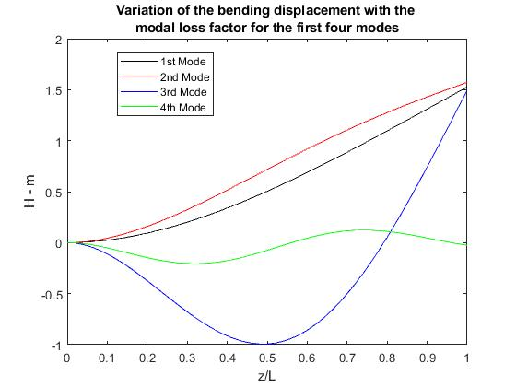

Figure 7. The variation of the bending displacement against the modal loss factor is obtained for a coupled bending-torsional composite beam

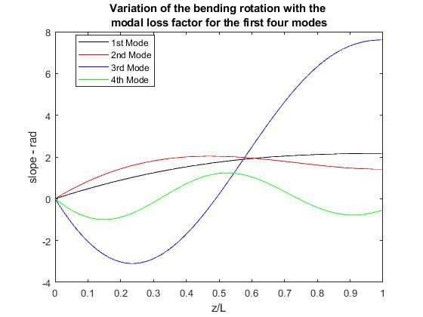

Figure 8. The variation of the bending rotation against the modal loss factor is obtained for a coupled bending-torsional composite beam

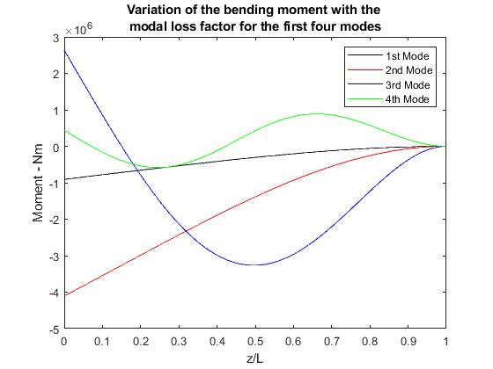

Figure 9. The variation of the torsional rotation against the modal loss factor is obtained for a coupled bending-torsional composite beam

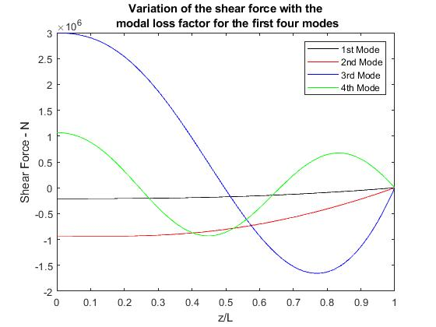

Figure 10. The variation of the shear force against the modal loss factor is obtained for a coupled bending-torsional composite beam



Figure 11. The variation of the bending moment against the modal loss factor is obtained for a coupled bending-torsional composite beam

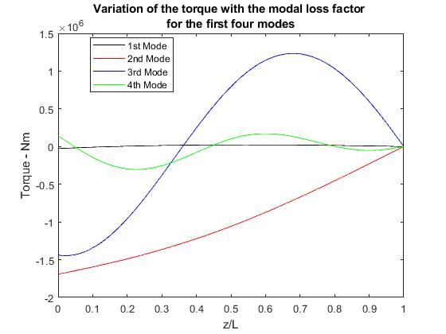

Figure 12. The variation of the torque against the modal loss factor is obtained for a coupled bending-torsional composite beam

It is clearly seen that for all three modes and the four different combinations of ${ x}_{α} and K$, the reference data are compared well with the result obtained over a wide frequency range.

In conclusion, it is demonstrated that the analysis presented in this paper is sufficiently accurate for engineering purposes to predict the dynamic response of a bending-torsion coupled composite beam.

**Conclusion**

The free vibration characteristics of a coupled bending and torsional composite beam and its application to an aircraft wing have been studied using a boundary condition based method. The displacement and reactional matrix of a composite beam element was developed for boundary conditions of free end and fixed end respectively. The boundary condition matrix accounts for both geometric and material coupling and the analytical solutions of the governing equations provides a foundation for the study of coupled bending and torsional vibration of a composite beam.

The derived model applied to a no damping condition show good agreement with those reported in literature. As detailed in Table 2, for the first three modes, the natural frequencies obtained under similar conditions were very close to those previously reported, effectively validating the developed model.

The complex natural frequency of the system obtained from the variation of the determinant with the expected frequency and expected modal loss factor is used to derive the actual natural frequency and associated modal loss factor. The natural frequency obtained increased significantly from the first mode to the fourth mode, while the modal loss factor had a slight almost undetected increase as we move from the first mode all the way to the fourth mode. Also, the variation of modal parameters such as bending displacement, bending rotation, torsional rotation, shear force, bending moment and torque with the associated modal loss factor for four mode shapes are presented.

The theory developed and the analytical solutions obtained provides a basis for aeroelastic studies in which the effects of geometric and material coupling can be controlled in a beneficial way to achieve desirable objectives in the design of a composite beam such as the aircraft wing.

**REFERENCES**

[1] Banerjee JR., “Coupled bending–torsional dynamic stiﬀness matrix for beam elements,” International Journal for Numerical Methods in Engineering, Vol 28, 1989 pp. 1283–98.

[2] Banerjee JR, Williams FW, “Free vibration of composite beams – an exact method using symbolic computation,” Journal of Aircraft, Vol 32, 1995 pp. 636–42.

[3] Banerjee JR, Su H, Jayatunga C., “A dynamic stiffness element for free vibration analysis of composite beams and its application to aircraft wings,” Computer & Structures Journal, Vol 86, 2008 pp. 573-579.

[4] Wittrick WH, Williams FW., “A general algorithm for computing natural frequencies of elastic structures,” Quarterly Journal of Mechanics & Applied Mathematics, Vol 24, 1971 pp. 263–84.

[5] Hodges DH, Atilgan AR, Fulton MV, Rehﬁeld LW., “Free vibration analysis of composite beams,” Journal of the American Helicopter Society, Vol. 36, 1991 pp. 36–47.

[6] Armanios EA, Badir AM., “Free vibration analysis of anisotropic thin- walled closed-section beams,” AIAA Journal, Vol 33, 1995 pp. 1905–10.

[7] Abramovich H, Livshits A., “Free vibrations of non-symmetric cross- ply laminated composite beams,” Journal of Sound and Vibration, Vol. 176, 1994 pp. 597–612.

[8] Yuan FG, Miller RE., “A new ﬁnite element for laminated composite beams,” Computer & Structures Journal 1989; Vol 31, 1989 pp. 737–45.

[9] Chen WQ, Lv CF, Bian ZG., “Free vibration analysis of generally laminated beams via state-space-based diﬀerential quadrature,” Computer & Structures Journal Vol 63, 2004 pp. 417–25.

[10] Song O, Librescu L. “Free vibration of anisotropic composite thin- walled beams of closed cross-section,” Journal of Sound and Vibration, Vol 167, 1993 pp. 129–47.

[11] Eslimy-Isfahany SHR, Banerjee JR., “Dynamic response of composite beams with application to aircraft wings,” Journal of Aircraft, Vol 34, 1997 pp. 785–91.

[12] Qin Z, Librescu L., “Dynamic aeroelastic response of aircraft wings modeled as anisotropic thin-walled beams,” Journal of Aircraft, Vol 40, 2003 pp. 532–43.

[13] Kant T, Gupta A., “A ﬁnite element model for a higher-order shear- deformable beam theory,” Journal of Sound and Vibration, Vol 125, 1988 pp. 193–202.

[14] Chandrashekhara K, Krishnamurthy K, Roy S., “Free vibration of composite beams including rotary inertia and shear deformation,” Computer & Structures Journal, Vol 14, 1990 pp. 269–79.

[15] Marur SR, Kant T., “Free vibration analysis of ﬁbre reinforced composite beams using higher order theories and ﬁnite element modelling,” Journal of Sound and Vibration, Vol 194, 1996 pp. 337–51.

[16] Lottati I., “Flutter and divergence aeroelastic characteristics for composite forward swept cantilevered wing,” Journal of Aircraft, Vol 22, 1985 pp. 1001–7.

[17] Lottati I., “Aeroelastic stability characteristics of a composite swept wing with tip weights for an unrestrained vehicle,” Journal of Aircraft, Vol 24, 1987 pp.793–802.

[18] Goland M., “The ﬂutter of a uniform cantilever wing,” Journal of Applied Mechanics, Vol 12, 1945 pp. A197–208

[19] Grootenhuis P., “The control of vibrations with viscoelastic materials,” Journal of Sound and Vibration, Vol 11, 1970 pp. 421-33

**APPENDIX**

Detailed representation of the matrices in equations (49) and (50) have been shown below. For the fixed end, $ζ = 0$

$\left\{\begin{matrix}H \\ \begin{matrix}θ \\ ψ \\ \begin{matrix}S \\ \begin{matrix}M \\ T\end{matrix}\end{matrix}\end{matrix}\end{matrix}\right\}=\left[\begin{matrix}1 & 1 & 1 & 1 & 1 & 1 \\ α_{1} & -α_{1} & α_{2} & -α_{2} & α_{3} & -α_{3} \\ d_{11} & d_{12} & d_{21} & d_{22} & d_{31} & d_{32} \\ e_{11} & {-e}_{12} & e_{21} & {-e}_{22} & e_{31} & {-e}_{32} \\ {-f}_{11} & f_{12} & {-f}_{21} & f_{22} & {-f}_{31} & f_{32} \\ {-g}_{11} & g_{12} & {-g}_{21} & g_{22} & {-g}_{31} & g_{32}\end{matrix}\right]\left[\begin{matrix}A_{1} \\ A_{2} \\ A_{3} \\ A_{4} \\ A_{5} \\ A_{6}\end{matrix}\right]$

For the free end, $ζ =1$

$$\left\{\begin{matrix}H \\ \begin{matrix}θ \\ ψ \\ \begin{matrix}S \\ \begin{matrix}M \\ T\end{matrix}\end{matrix}\end{matrix}\end{matrix}\right\}=\left[\begin{matrix}{ep}_{1} & {em}_{1} & {ep}_{2} & {em}_{2} & {ep}_{3} & {em}_{3} \\ α_{1}{ep}_{1} & -α_{1}{em}_{1} & α_{2}{ep}_{2} & -α_{2}{em}_{2} & α_{3}{ep}_{3} & -α_{3}{em}_{3} \\ d_{11}{ep}_{1} & d_{12}{em}_{1} & d_{21}{ep}_{2} & d_{22}{em}_{2} & d_{31}{ep}_{3} & d_{32}{em}_{3} \\ e_{11}{ep}_{1} & {-e}_{12}{em}_{1} & e_{21}{ep}_{2} & {-e}_{22}{em}_{2} & e_{31}{ep}_{3} & {-e}_{32}{em}_{3} \\ {-f}_{11}{ep}_{1} & f_{12}{em}_{1} & {-f}_{21}{ep}_{2} & f_{22}{em}_{2} & {-f}_{31}{ep}_{3} & f_{32}{em}_{3} \\ {-g}_{11}{ep}_{1} & g_{12}{em}_{1} & {-g}_{21}{ep}_{2} & g_{22}{em}_{2} & {-g}_{31}{ep}_{3} & g_{32}{em}_{3}\end{matrix}\right]\left[\begin{matrix}A_{1} \\ A_{2} \\ A_{3} \\ A_{4} \\ A_{5} \\ A_{6}\end{matrix}\right]$$

Where the matrix elements are

$$e_{11}=\frac{EIα_{1}^{3}}{L^{3}}+\frac{KK_{α_{1}}}{L^{3}(1+g_{α_{1}})}, e_{12}=\frac{EIα_{1}^{3}}{L^{3}}+\frac{KK_{α_{1}}}{L^{3}(-1+g_{α_{1}})}$$

$$e_{21}=\frac{EIα_{2}^{3}}{L^{3}}+\frac{KK_{α_{2}}}{L^{3}(1+g_{α_{2}})}, e_{22}=\frac{EIα_{2}^{3}}{L^{3}}+\frac{KK_{α_{2}}}{L^{3}(-1+g_{α_{2}})}$$

$$e_{31}=\frac{EIα_{3}^{3}}{L^{3}}+\frac{KK_{α_{3}}}{L^{3}(1+g_{α_{3}})}, e_{32}=\frac{EIα_{3}^{3}}{L^{3}}+\frac{KK_{α_{3}}}{L^{3}\left(-1+g_{α_{3}}\right)}$$

$$f_{11}=\frac{EIα_{1}^{2}}{L^{2}}+\frac{Kα_{1}K_{α_{1}}}{L^{2}\left(1+g_{α_{1}}\right)}, f_{12}=\frac{EIα_{1}^{2}}{L^{2}}+\frac{Kα_{1}K_{α_{1}}}{L^{2}(-1+g_{α_{1}})}$$

$$f_{21}=\frac{EIα_{2}^{2}}{L^{2}}+\frac{Kα_{2}K_{α_{2}}}{L^{2}\left(1+g_{α_{2}}\right)},f_{22}=\frac{EIα_{2}^{2}}{L^{2}}+\frac{Kα_{2}K_{α_{2}}}{L^{2}\left(-1+g_{α_{2}}\right)}$$

$$f_{31}=\frac{EIα_{3}^{3}}{L^{2}}+\frac{Kα_{3}K_{α_{3}}}{L^{2}\left(1+g_{α_{3}}\right)},f_{32}= \frac{EIα_{3}^{3}}{L^{2}}+\frac{Kα_{3}K_{α_{3}}}{L^{2}\left(-1+g_{α_{3}}\right)}$$

$$g_{11}=\frac{Kα_{1}^{2}}{L^{2}}+\frac{GJα_{1}K_{α_{1}}}{L^{2}\left(1+g_{α_{1}}\right)},g_{12}= \frac{Kα_{1}^{2}}{L^{2}}+\frac{GJα_{1}K_{α_{1}}}{L^{2}(-1+g_{α_{1}})}$$

$$g_{21}=\frac{Kα_{2}^{2}}{L^{2}}+\frac{GJα_{2}K_{α_{2}}}{L^{2}\left(1+g_{α_{2}}\right)},g_{22}=\frac{Kα_{2}^{2}}{L^{2}}+\frac{GJα_{2}K_{α_{2}}}{L^{2}\left(-1+g_{α_{2}}\right)}$$

$$g_{31}= \frac{Kα_{3}^{3}}{L^{2}}+\frac{GJα_{3}K_{α_{3}}}{L^{2}\left(1+g_{α_{3}}\right)},g_{32}=\frac{Kα_{3}^{3}}{L^{2}}+\frac{GJα_{3}K_{α_{3}}}{L^{2}\left(-1+g_{α_{3}}\right)}$$

$${ep}_{1}= e^{α_{1}}, {ep}_{2}= e^{α_{2}},{ep}_{3}= e^{α_{3}}$$

$${em}_{1}= e^{{-α}_{1}}, {em}_{2}= e^{{-α}_{2}},{em}_{3}= e^{-α_{3}}$$